Linux And Security Article

1. Task-01 : installation of MySQL and services details

# apt install mysql-server

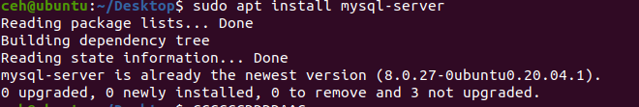

# apt install mysql-client

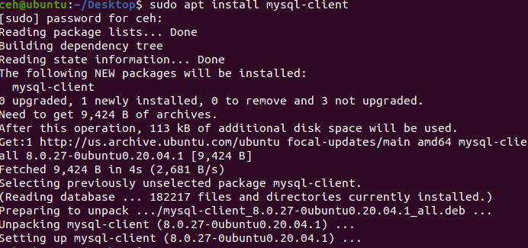

To check Mysql services running or not

# systemctl status mysql

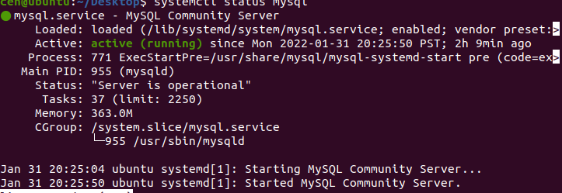

Running Python Codes on Linux:

1. Installation of Python:

# sudo apt-get install python

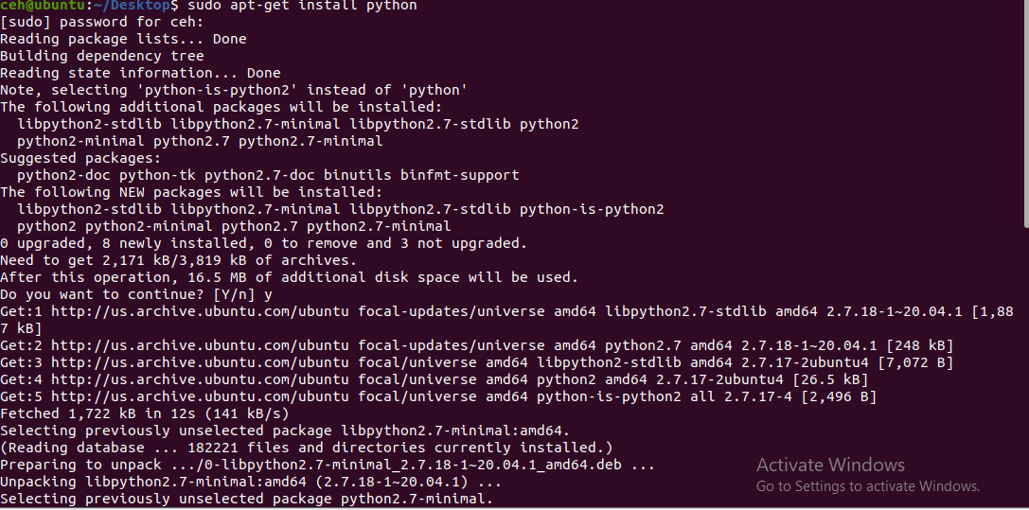

1. Installation of Gedit :

# sudo apt-get install gedit

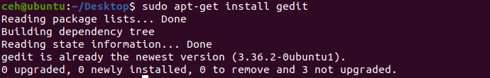

1. Write Python code :

# sudo gedit samplepython.py

Sample code

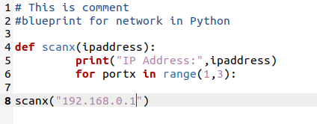

1. Running

